Contestant Number: ____________________
Time: ___________________
Rank: _______________



BANKING AND FINANCE
(145)

NATIONAL 2024

CONCEPT KNOWLEDGE:

Objective Questions (25 @ 2 points each) ________________ (50 points)
APPLICATION KNOWLEDGE:
Short Answer Questions (14 @ 3 points each) ________________ (42 points)
Job 1: Loan Repayment Schedule ________________ (39 points)
Job 2: Credit Card Finance Charges ________________ (12 points)

TOTAL POINTS ________________ (143 points)

Test Time: 60 minutes

GENERAL GUIDELINES:
Failure to adhere to any of the following rules will result in disqualification:
- Member must hand in this test booklet and all printouts if any. Failure to do so will result in disqualification.
- No equipment, supplies, or materials other than those specified for this event are allowed in the testing area. No previous BPA tests and/or sample tests (handwritten, photocopied, or keyed) are allowed in the testing area.
- Electronic devices will be monitored according to ACT standards.
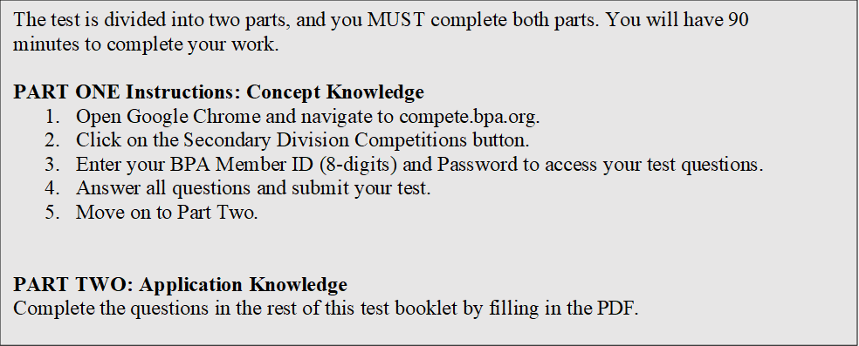
EXAM GUIDELINES:

You have been hired as a Financial Assistant and will be keeping the accounting records for Digital Solutions, located at 700 Morse Road, Suite 201, Columbus, Ohio 43214. Digital Solutions provides accounting and other financial services for clients. You will complete jobs for Digital Solutions’ own accounting records, as well as for clients.

You will have 60 minutes to complete your work. The test is divided into two parts: concept knowledge and application knowledge.

Your name and/or school name should not appear on any work you submit for grading. Write your Member ID in the provided space. Staple all pages in order before you turn in your test.

Assumptions to make when taking this assessment:
- Round all calculations to two decimals at the final step.
- Round all percentages to one decimal place.
- Use 360 days for interest calculations.

Multiple Choice Questions (50 points)

Directions: Identify the letter of the choice that best completes the statement or answers the question.

- If a business wants to know whether it has enough cash, or items that can be turned into cash quickly, to pay its short-term debts, it will look at its ______ ratio.
  - Debt-to-Equity
  - Current
  - Return on Equity
  - Net Income

- The ______ is a financial statement that show’s a company’s financial status on a specific day.
  - Income Statement
  - Statement of Stockholders Equity
  - Balance Sheet
  - Cash Flow Statement

- Butler Co. bought the following rolls of paper towel during March:
March 5 5 Rolls @ $2.50
March 11 10 Rolls @ $2.40
March 21 6 Rolls @ $2.60
During the month, 17 rolls were used. If Butler uses the FIFO method to value ending inventory, which rolls remain inventory?
  - The rolls purchased on March 5
  - The rolls purchased on March 11
  - The rolls purchased on March 21
  - There is no way to tell which rolls are left

- A 401K is an example of a mutual fund.
  - True
  - False

- Which of the following cannot legally be used as collateral for a loan?
  - Retirement Account
  - Savings Account
  - Car
  - Life Insurance Policy

- A type of stock that features companies that lead their respective industries and have gained strong reputations.
  - Growth Stock
  - Penny Stock
  - Preferred Stock
  - Blue Chip Stock

- What does inflation do to the value of money?
  - Makes it go up.
  - Makes it go down.
  - Keeps it at a constant.
  - Has no effect on its value.

- The primary role of the Federal Reserve Bank is to steer the economy by ______.
  - Controlling the budget.
  - Loaning out money.
  - Setting spending levels.
  - Controlling the money supply.

- Which of the following statements about bonds is false?
  - Governments and companies commonly use bonds to borrow money.
  - The interest rate is called the coupon rate.
  - The prices of bonds vary every day.
  - Bonds pay lower returns than stocks.

- The money paid to an insurance company for a life insurance policy is called the ______.
  - Premium
  - Principle
  - Down payment
  - Lien

- With an amortized car loan, the amount of interest that makes up each payment ______.
  - increases each month.
  - decreases each month.
  - stays the same each month.
  - fluctuates depending on how the interest rate changes.

- The amount of property tax paid is based on the property’s ______ value.
  - Authorize
  - Fair Market
  - Default
  - Assessed

- A fee charged to borrow money is called ______.
  - Interest
  - Inflation
  - Discount Rate
  - Reserve Requirement

- Another name for a dividend stock is a(n) ______ stock.
  - Growth
  - Value
  - Income
  - Common

- A home equity loan is an example of closed-end credit.
  - True
  - False

- The amount of income on which a person pays tax is their ______.
  - Gross Income
  - Adjusted Gross Income
  - Exempt Income
  - Taxable Income

- The central bank of the United States is the ______.
  - U.S. Treasury Bank
  - U.S. National Bank
  - Federal Reserve Bank
  - Comptroller’s Bank

- The cost of interest expressed as a yearly interest rate is called the ______,
  - ACH
  - AYP
  - ATM
  - APR

- An equity investment will do better when there is a bull market.
  - True
  - False

- An economic measurement that calculates how much the prices of goods and services typically bought by consumers have changed is the ______.
  - Inflation Rate
  - GDP
  - CPI
  - Standard of Living

- Which one of the following is prime cost for a manufacturer?
  - Cost of Raw Materials
  - Wages of Factory Managers
  - Factory Supplies
  - Building Rent

- Which of the following is not an adjustment to income for income tax purposes?
  - Alimony
  - Medical expenses
  - Payments to approved retirement plans
  - Business losses

- The minimum amount that a bank must have on hand is its required reserve.
  - True
  - False

- A federal income tax that provides retirement, disability, and survivor benefits is
  - Federal Unemployment Tax
  - Medicare Tax
  - Social Security Tax
  - Worker’s Compensation Tax

- Investments are not FDIC insured and as a result the owner could risk losing them.
  - True
  - False

Short Answer Questions (2 points each; 28 points total)
- The court declared Steinman, Inc. bankrupt and the trustee sold its assets for $259,000. Legal costs of bankruptcy and other claims the courts required to be paid first totaled $70,000. Creditors’ claims total $420,000. Fisher, Inc. had a claim for $2,700.

  - How much is available to creditors? ________________________________________

  - How many cents on the dollar will the creditors get? ___________________________

  - How much will Fisher, Inc. get? ________________________

- The Bennington Income Fund trades at a net asset value of $34.88 and an offer price of $36.46.

  - What commission amount is paid per share? ___________________________

  - What is the commission rate? Round to the nearest tenth percent. ___________________

  - Stirling Jacobs bought 300 shares of stock for $21,577.50. Two years later he sold it for $65.49 NAV. What was his total profit or loss? _________________________________

- Find the interest and amount due at maturity for each promissory note.

 | Face of Note | Time | Annual Rate | Interest | Amount Due at Maturity
(a) | $600 | 3 yr. | 12%
(b) | $150 | 3 mo. | 18%
(c) | $950 | 2 ¼ yr. | 5 ½%
(d) | $2,500 | 2 yr. | 15%

JOB 1: Loan Repayment Schedule (39 points)

Angela Byers borrowed $1,000 on a one-year simple interest installment loan at 15% APR. The monthly payments were $90.26. Find the amount of interest, amount applied to the principal, and the new balance for each month and record them in the Loan Prepayment Schedule below.

Month | Monthly Payment | Interest Payment | Applied to Principal | Balance
1 | $90.26
2 | $90.26
3 | $90.26
4 | $90.26
5 | $90.26
6 | $90.26
7 | $90.26
8 | $90.26
9 | $90.26
10 | $90.26
11 | $90.26
12 | $90.26
Totals

JOB 2: Credit Card Finance Charges (12 points)
Use the information in the table below to find the finance periodic rate and finance charge for each example. Use 365 days for interest calculations. The periodic rate should be rounded to the nearest ten-thousandth.

Balance Subject to  Finance Charge | APR | Period | Periodic Rate | # of Periods | Finance  Charge
$321.75 | 15% | Monthly |  | 1 Month
$78.91 | 18% | Daily |  | 30 Days
$941.48 | 12% | Monthly |  | 1 Month
$2,572.84 | 21% | Daily |  | 31 Days
$400.00 | 9% | Monthly |  | 1 Month
$7,937.37 | 10% | Daily |  | 30 Days

